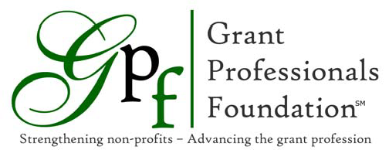

Be a Star Campaign 2021

The 2021 Be a Star Campaign is a nationwide campaign asking all GPA Chapters and GPA members to support the Grant Professionals Foundation Scholarship Program.
Why Give to the Campaign
- Help grow the grant profession by encouraging GPA membership
- Provide the means for new grant professionals to improve their skills and knowledge
- Enhance the credibility of the grant profession by supporting GPC credentialing
- Support grant professionals who have limited resources to pursue professional development
- Make an impact on nonprofit organizations across the country that are able to do more and do it better because of the expertise of their grant professionals.
Campaign funds are used to award scholarships for:
- GPA Annual Conference
- GPCTM Credentialing Program
- GPA Membership
- Regional Conference Sponsorships, when funds permit
Either individuals or chapters can donate to the campaign.
Individual member gifts:
Check out the GPF website donation page at https://grantprofessionalsfoundation.org/donations/ Donations can be unrestricted (to be used at the Foundation’s discretion) or assigned to a GPA Chapter to count toward the Star Chapter contest. In addition, funds can be assigned to an existing named scholarship or given in honor/memory of someone. Online gifts through the website are safe and secure.
Chapter Donations:
Star Chapter: Chapters compete for the distinction of becoming the 2021 Star Chapter by giving the most to the Be a Star Campaign. The 2021 Star Chapter is announced at the annual Chapter Leaders Conference and publicized on social media and the GPA website. Individual donations assigned to a chapter or donations sent in from the chapter using the online donation form count toward the contest.
First Place receives two GPA membership scholarships and 2nd and 3rd place receive 1 scholarship each.
Contact Information
Susan Caldwell, Be a Star Chair Helen Arnold, GPF Treasurer
susancaldwell1962@gmail.com helen@arnoldolson.com
606-269-4950 702-485-3224

